Отчёта по лабораторной работе №1

Практическое научное письмо

Коне Сирики

Содержание

Список иллюстраций

Список таблиц

# 1 Цель работы

Целью данной лабораторной работы является установка TexLive

# 2 Теоретическое введение

### 2.0.1 Installing TeXlive

**TeX Live** — the most complete LaTeX distribution supported by the TeX community. • Supports a large number of operating systems. • Developed since 1996. • Based on the teTeX distribution. • MacTeX — a variant for MacOS. • Main page: https://www.tug.org/texlive/.• • TeX Live — is a distribution with continuous updates as part of the annual version of the distribution.

**Installation from distribution packages** [1]

• Ubuntu: apt install texlive-full

• Windows. Use the Chocolatey package manager. choco install texlive

### Manual installation

• Links on the site are to mirrors. The mirror is selected automatically. • Download the installer: • Unix: https://mirror.ctan.org/systems/texlive/tlnet/install-tl-unx.tar.gz cd /tmp/ wget  
https://mirror.ctan.org/systems/texlive/tlnet/install-tl-unx.tar.gz • Windows: https://mirror.ctan.org/systems/texlive/tlnet/install-tl-windows.exe • For Windows: run the executable file and install. • For Linux • Unpack the downloaded file: tar xzvf install-tl-unx.tar.gz • Go to the unpacked directory and run the installer: cd install-tl-[0-9]* sudo ./install-tl • It is recommended to create links to executable files in the /usr/local/bin directory. To do this, in the console version of the utility, select the O option, and then L. To return to the previous menu, use R.

# 3 Updating to the next version of TeXlive

It is recommended to install the new version of TeX Live separately.

• But you can do a manual update using an existing installation. • Let’s assume that our architecture is x86_64-linux. • If you have installed symbolic links to system directories (via installer option or tlmgr path add), remove them:

1.1 Installing TeX Live

tlmgr path remove

• Move the entire TeX Live directory to match the new version, for example:

mv /usr/local/texlive/2024/ /usr/local/texlive/2025

• Remove package backups:

rm /usr/local/texlive/2025/tlpkg/backups/*

• Create links to executables:

/usr/local/texlive/2025/bin/x86_64-linux/tlmgr path add

• Download the latest version of the script update-tlmgr-latest.sh:

wget https://mirror.ctan.org/systems/texlive/tlnet/update-tlmgr-latest.sh \  
-O /tmp/update-tlmgr-latest.sh

• Run the script:

sh /tmp/update-tlmgr-latest.sh --upgrade

• If you do not want to use the default repository for downloading new files, then replace it:

tlmgr option repository <reponame>

• Update the TeX Live package manager:

tlmgr update --self

• Update TeX Live packages:

tlmgr update --all

• Set symbolic links to executables in system directories (/usr/local/bin):

tlmgr path add

## 3.1 1 LaTeX basics

• You can recreate the cache lualatex under the user:

mv ~/.texlive2024 ~/.texlive2025  
luaotfload-tool -fu

• If you don’t do this, the cache will be recreated on the first run of lualatex.

# 4 Выполнение лабораторной работы

## 4.1 Перед установка teXlive

(см. Рис. **¿fig:001?**).

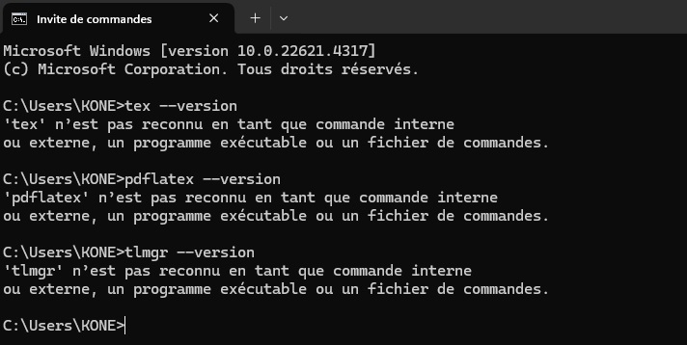

## 4.2 После установки teXlive

(см. Рис. **¿fig:002?**).

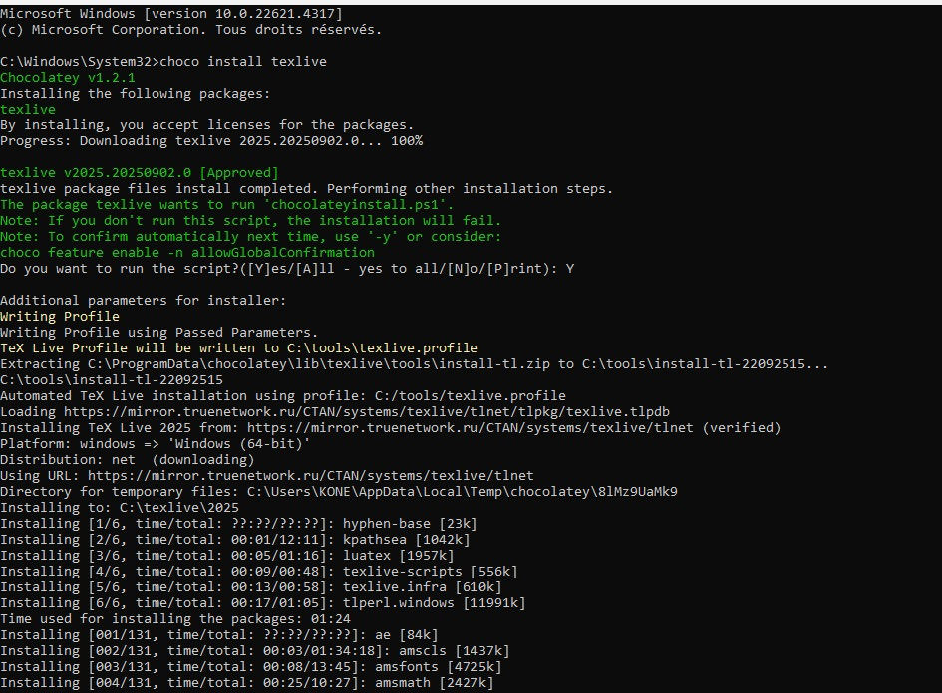

(см. Рис. **¿fig:003?**).

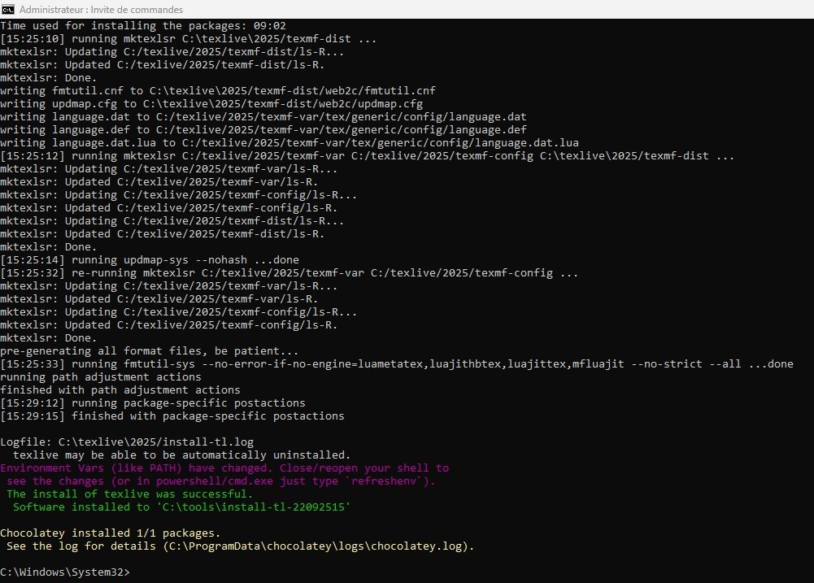

## 4.3 Проверка установление teXlive

(см. Рис. **¿fig:004?**).

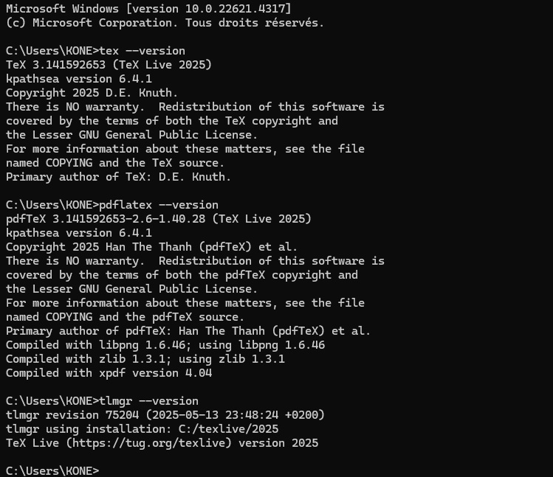

# 5 Выводы

Таким образом, была достигнута цель установил TeXlive.

# Список литературы

1. Жданов О., Ушаков Ю. Криптографические методы защиты информации. Лекция 2: Алгоритмы тестирования на простоту и факторизации. НОУ «ИНТУИТ» <https://intuit.ru/studies/courses/13837/1234/lecture/31191>, 2014.